85 Bath Road
Service User Guide
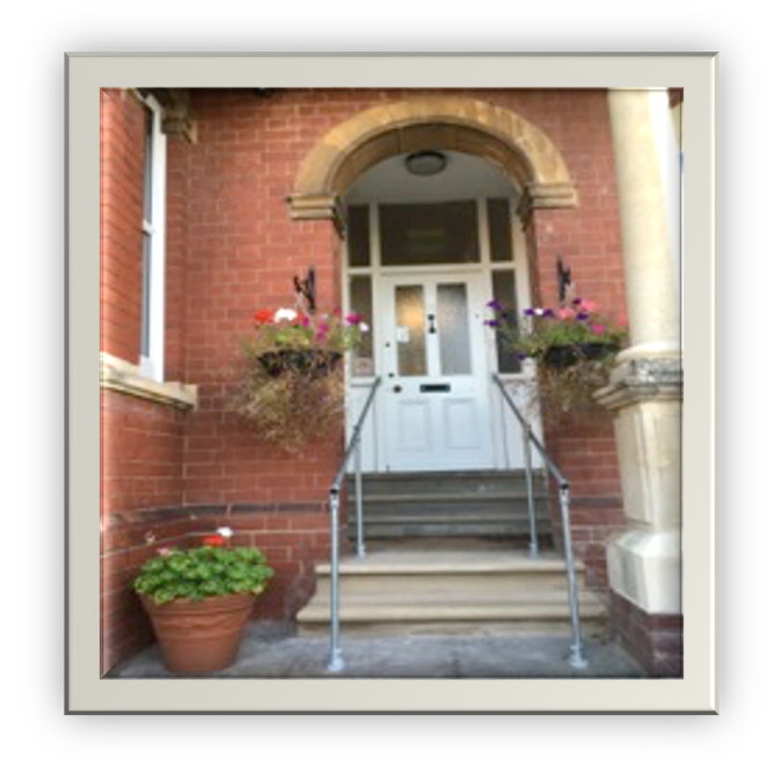
Residential Care Home for Deaf Adults with Autism and Learning Disabilities

85 Bath Road, Worcester, WR5 3AE | Tel: 01905 360439 | Email - 85.bathroad@thebroadgroup.co.uk www.thebroadgroup.co.uk
Head Office| 12 Astwood Road, Worcester, WR3 8ET | Tel: 01905 330600 |Email - info@thebroadgroup.co.uk

Table of Contents

About Us 3
Support and Facilities 4
Our Fees 6
Our Approach 7
Communal Space and Individual Accommodation 8
Complaints Procedure 9

About Us
Thank you for taking the time to read through this document, it summarises basic information about our Residential Care Home at 85 Bath Road. The information is intended to provide guidance about the services we provide for our existing service users and individuals who are considering using our service.
Family run since 1989 Ted and Roma Broadbent set up 85 Bath Road Residential Care Home for young deaf adults with autism and learning difficulties. Prior to setting up the Care Home both of them taught deaf children with autism. When they retired their son David and his wife Kirsty took over the running of the business.
Ted and Roma
≈
In 2019 Kirsty and David’s eldest son Noah took over as Managing Director. Noah, joined the family business at a young age, working part-time as a Support Worker whilst studying Business Management at Worcester University
David and Kirsty
≈
Noah
≈
85 Bath Road still offers specialist residential care for profoundly deaf adults (18 to 65 years +) with autism and learning disabilities and is registered with the Care Quality Commission to provide residential care for five adults.
We aim to respect the fundamental rights of each service user. We believe that our core values underpin the whole philosophy of the care that is provided.
We can meet a wide range of individual needs, which would be determined through initial assessment, however we are unable to provide nursing care on a long-term basis and regretfully due to the nature of the house, we are unable to accommodate any wheelchair users.
“Something rather special …………an ordinary life”
We pride ourselves in providing a warm, friendly and homely environment with the highest quality of care where the welfare and wellbeing our service users is at the heart of what we do.

Our Team
Our well-established team of both full and part-time staff comprise of people with a wide range of skills, experience and qualifications. They are all trained to work with autistic adults that display challenging behaviour.
All staff new to the Learning Disability Sector undertake the ‘Care Certificate Induction Programme’. The Broad Group is committed to the training and development of all staff. Each staff member has their individual training needs identified and the appropriate training is planned and certificated. All staff either hold or are working towards BSL Stage 1
Our staff turnover is low, many of our staff have worked with for a number of years. The team are all committed to ensuring our service users lead a fulfilling and contented life.
All staff are specially trained to support service users who have an Autistic Spectrum Disorder and who present challenging behaviours.

Our Registered Manager
Ms Josephine Fowler is our Registered Manager. Josephine started her career with the Broad Group in 1994 as a support worker and progressed to the role of Registered Manager, a position she held for 20 Years until she took early retirement in 2019. Two years later she returned as Care Quality Advisor and in 2023 when the Registered Manager resigned, she returned to the role.

Support and Facilities

Prior to Admission
Potential Service Users have their needs thoroughly assessed so they can make an informed choice about their future. For potential Service Users who are already in touch with a Social Service Department, the initial assessment is undertaken as part of the Care Management process. We also need to assure ourselves and the Service Users already resident at the Home that this Home is suitable for them.
For potential Service Users approaching the Home directly, appropriately trained staff will make a full assessment of their needs. This process enables us, to make sure that we can meet the needs of the individual and to make a plan of care. We will provide prospective Service Users with as much information as possible about the Home to assist in their decision.
We offer the opportunity for a prospective Service User to visit the Home, join in with meals or activities and to have a short stay on a trial basis. The first visit to the Home will have no funding implications; however, any subsequent trial visits will incur costs, usually at a rate pro-rata to the basic weekly fee, dependant on the length of stay. We would actively encourage the involvement of family and friends in the decision process.

Trial Visit
Provide Information
Assessment

Admission
Admission to the Home will only be considered following a detailed assessment and thorough collaboration with all involved with their care. Soon after admission to the Home, each Service User is allocated a keyworker and a 3-month trial period is set. During this time the new Service User is continually assessed, monitored and reviewed against their own ‘Service User Plan’. Subsequent reviews take place, initially at quarterly intervals reducing to annually with professional agency input.

Emergency Admission
We are unable to accept emergency admissions.

Occupancy
Service Users will be given exclusive use of a single bedroom. Details of the Service Users room will be made clear in their individual “Terms of Residence” contract. This will remain as their room for the duration of their residence unless it is mutually agreed that they move to occupy another bedroom. Any such decision will be made after proper process following a review of care provision.

Termination of contract
The “Terms of Residence” contract shall continue in force until terminated by either party giving to the other written notice four weeks before termination. Should the Service User leave the Home without giving the required notice, payment of fees in lieu of notice at the normal weekly rate will be required.

Our Fees
The basic fees start from £1,809 per week (gross). This excludes the cost of any specific additional 1:1 support required. Any additional support will be charged pro-rata and according to identified and assessed needs.
Fees are to be paid four weekly: two weeks in advance and two weeks in arrears by direct credit (via standing order) or by cheque or standing order.

What is included and not included in the fees

Included in fees |  | Not included in fees
 | Furnished individual accommodation as well as access to communal areas |  | Transport costs
 | Laundry services |  | Newspapers, magazines or other publications
 | Food & drinks, including all main meals and snacks |  | Hairdressing, chiropractor or other services on demand
 | Provision of some basic toiletries; soap, shampoo, toothpaste, etc. |  | Digital subscriptions

Our Approach
This Home tries to work in a way that is open, positive and inclusive. We therefore welcome comments and suggestions from Service Users and their representatives, friends and relatives. Positive comments help us to identify where we are doing well and to build on that success. However, we can also learn from comments that are critical of the Home or the staff. We undertake to investigate negative comments or complaints, as quickly as possible and to provide a response, which we hope, will satisfy the person who has complained.
The ‘Service User Plan’ sets out the objectives of care, how they will be met, and is an ever- evolving document, reviewed on a regular basis to ensure the needs of an individual are continually met allowing for change and development. As far as possible all Service Users are encouraged to participate in the care planning process.

Planning for a Positive Outcome
Activities are tailored to the Service User’s particular needs, offering something very special - the opportunity to lead an ordinary life. Families are encouraged to visit whenever they choose to come. We offer a wide range of activities to suit everyone both in house and out in the community.
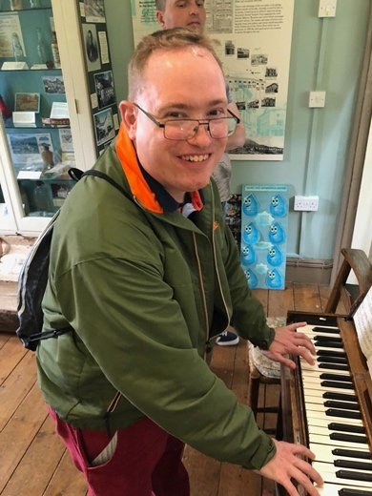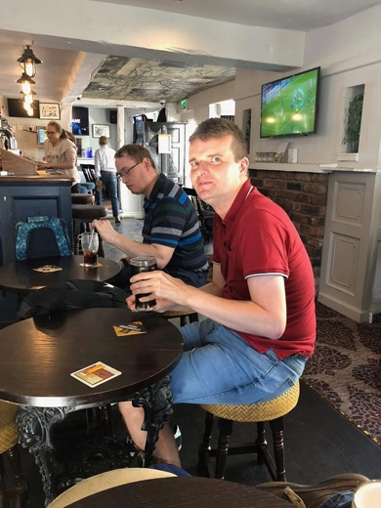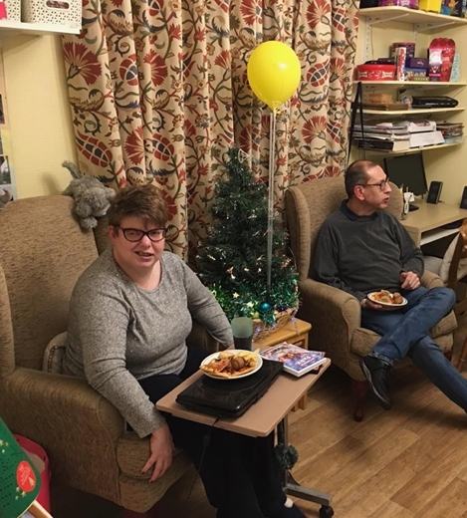

All Service Users are involved in the development of their daily plans, choosing from a range of options tailored to their individual likes and needs. For new Service Users to the Home, we would endeavour to continue any existing activities and interests once resident at the home.
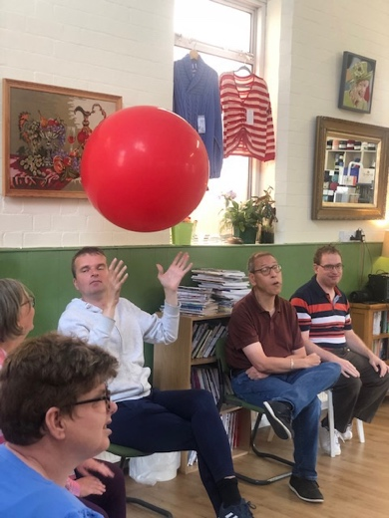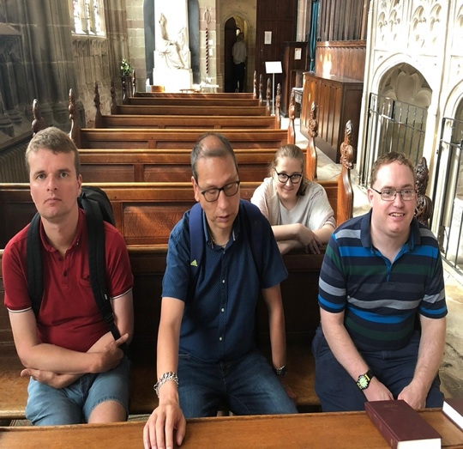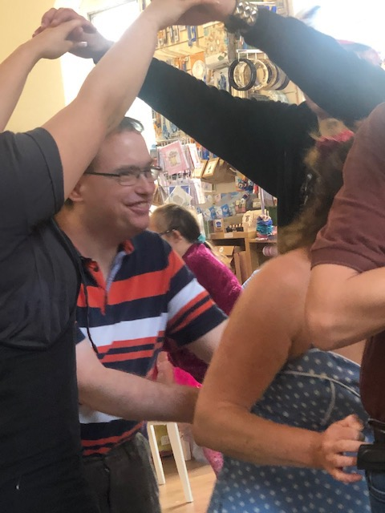

Communal Space and Individual Accommodation
The physical environment of the Home is designed for the Service Users convenience and comfort. The communal area on the ground floor comprises of a large sitting/TV room, dining room, kitchen and a utility room.
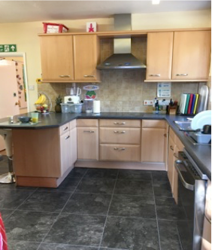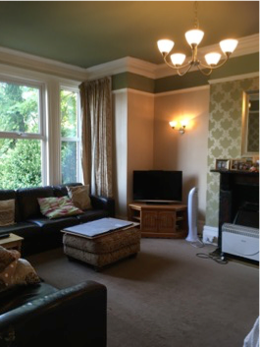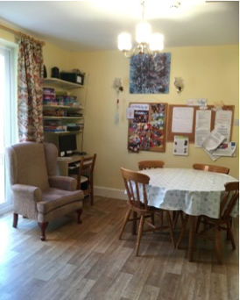
We recognise that mealtimes play an important part in the social life of the home. The dining room and lounge provide a welcoming and homely environment where social interaction is encouraged. All food is freshly cooked with nutritious ingredients and the emphasis is on providing a balanced and healthy menu.
There are five bedrooms for Service Users, all of which are for single occupation with at least 10sq metres of usable floor space. All bedrooms are fitted with wash hand basins and three rooms have en-suite shower there is also a staff office and a bedroom for staff sleeping overnight.
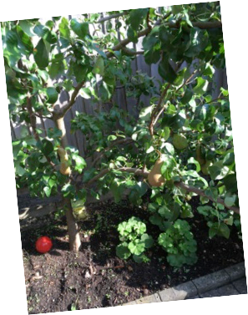
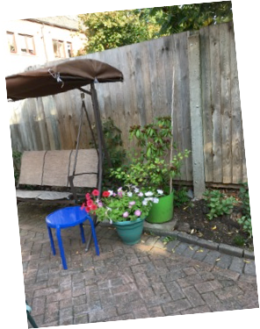
Each Service User has exclusive use of a single bedroom
85 Bath Road has a landscaped front garden and a patio back garden which Service Users are free to use and are able to develop any interests in gardening.

Complaints Procedure

Our Approach
This Home tries to work in a way that is open, positive and inclusive. We therefore welcome comments and suggestions from Service Users and their representatives, friends and relatives. Positive comments help us to identify where we are doing well and to build on that success. However, we can also learn from comments that are critical of the Home or the staff. We undertake to look into negative comments or complaints, as quickly as possible and to provide a response, which we hope, will satisfy the person who has complained.

Dealing with Complaints Informally
Anyone who feels dissatisfied with any aspect of the Home should, if possible, raise the matter in the first instance with a responsible member of staff. It may be that the staff member can take immediate action to respond to the point and if necessary to apologise. If the complaint is about the behaviour of a particular member of staff, and the complainant feels uncomfortable about raising it with them directly, the complaint should be made to someone more senior.
Any staff member receiving a complaint about themselves or a colleague will try to sort out the matter as quickly as possible.

Making a Formal Complaint
If anyone who is dissatisfied with any aspect of the Home feels that when they raised the matter informally it was not dealt with to their satisfaction, or the matter is too serious to be handled informally, or they feel uncomfortable about dealing with the matter on an informal basis, they should inform the Manager of the Home that they wish to make a formal complaint. The Manager will then make arrangements to handle the complaint personally. The person who is handling the complaint will then interview the complainant and will either set down the details in writing or provide the complainant with a form for them to fill in themselves.

Recording and Investigating a Complaint
The written record of a complaint on a complaint's form, whether it is completed by the person handling the complaint or by the complainant themselves, must be signed by the complainant. The complainant will be provided with a copy of this completed form, together with a written acknowledgement that the complaint is being processed, outlining the timescale for responding, explaining that the complainant has the right at any stage to pursue the matter with the Care Quality Commission of how the CQC can be contacted.
The person handling the complaint will then investigate the matter, interviewing any appropriate staff. If it is necessary to interview other service users or anyone else, the complainant's permission will be sought. Complaints will be dealt with confidentially and only those who have a need to know will be informed about the complaint or the investigation.
The investigation will be completed within 28 days unless there are exceptional circumstances, which will be explained to the complainant.
The person investigating the complaint will report back to the complainant, as soon as possible, explaining what they have found and providing them with a written copy of their report.

Action following an investigation into a complaint
The person who investigates a complaint will initiate any action which needs to be taken in response to their findings, will inform the complainant about any action, and will apologise or arrange for an apology if that is appropriate. We hope that this will satisfy the complainant and end the matter. If the complainant is satisfied, they will be asked to sign a copy of the report of the investigation and the action taken.

Complaints who are not satisfied
Clients or their representatives are encouraged to ask any member of staff for further information on matters which they genuinely do not understand.
Occasionally, the response may not be seen to be adequate, in which case it is important to seek an answer from the Directors at the earliest possible time.
The Directors will then investigate the circumstances and attempt to resolve the problem(s)
In the event of the problem being unsatisfactorily resolved, the issue may be serious enough to involve the local authority. If it is felt that the problem has not been resolved by the local Authority, the final steps need to be with the local Commissioner for Administration (Ombudsman):
Local Authority:
Worcestershire County Council – www.worcestershire.gov.uk
Worcester City Council – www.worcester.gov.uk
The Local Government Ombudsman - www.lgo.org.uk
PO Box 4771 Coventry
CV4 0EH
Tel: 0300 061 0614 Fax: 024 7682 0001
Furthermore, the Care Quality Commission states that although it welcomes hearing about any concerns, it will not investigate any individual complaints directly. Any complaints lodged with the C.Q.C. will be used as evidence during the assessment procedure when ensuring homes are compliant with the inspection process. They can be contacted at:
Care Quality Commission National Contact Centre, Citygate
Gallowgate
Newcastle upon Tyne
NE1 4PA
Tel: 03000 616161
Email: enquires@cqc.org.uk www.cqc.org.uk

